Precal lesson-build new functions
Name:
Class:
Date:

TN Standard: P.F.IF.A.2: Develop an understanding of functions as elements that can be operated upon to get new functions: addition, subtraction, multiplication, division, and composition of functions.

Lesson objective:
Students will be able to combine functions using algebraic operations. Students will be able to create a new function by composition of functions. Students will be able to evaluate new function values.

I DO/WE DO:
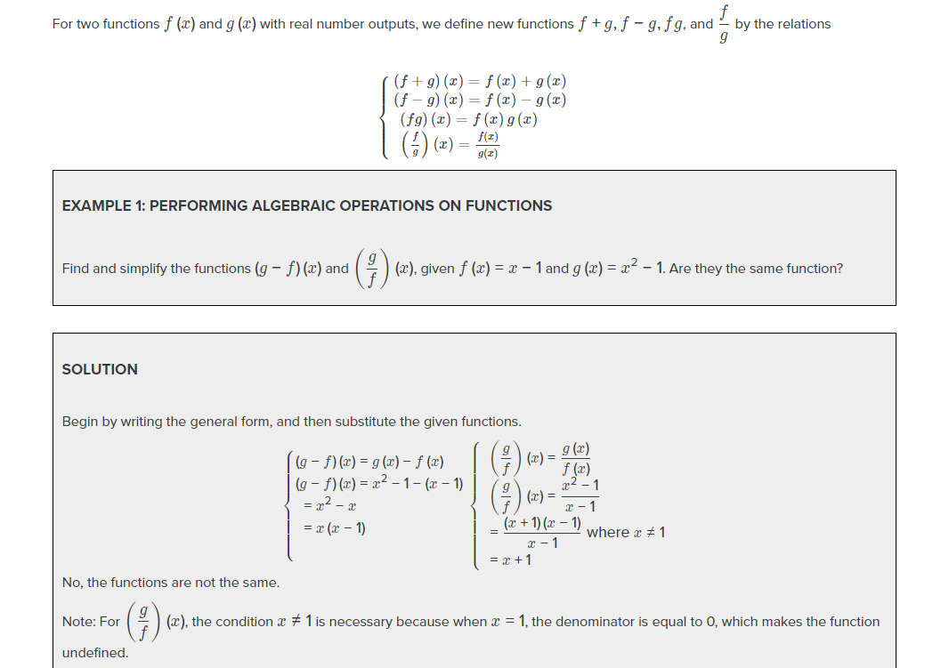

They Do:
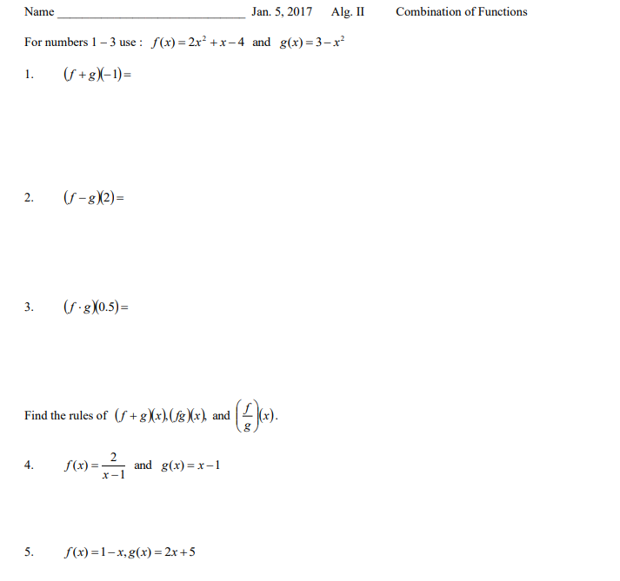

You Try It.

I DO/WE DO:
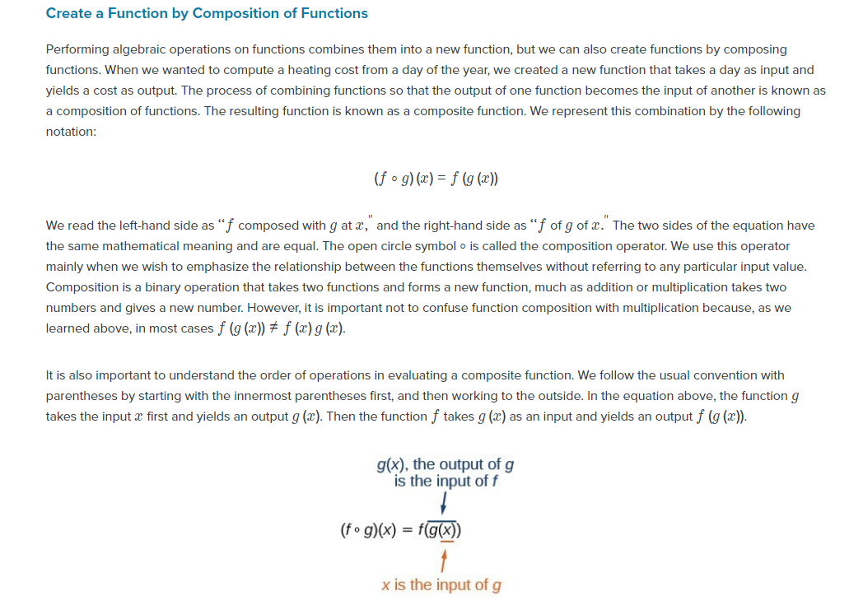

They Do:
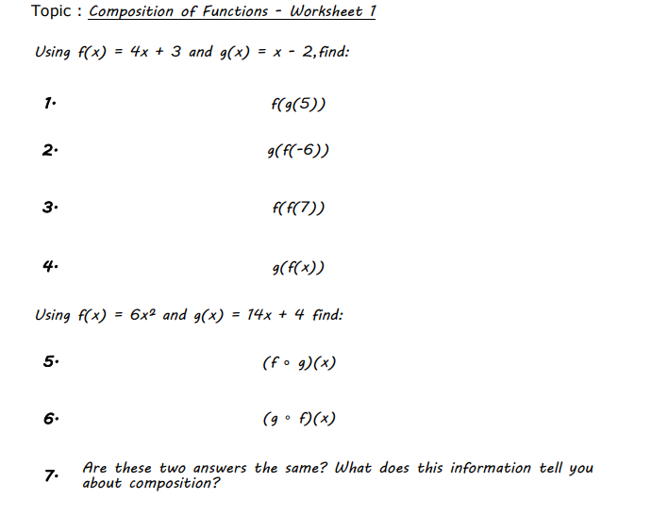

You Try It:

Exit ticket.

